CLASS : L.K.G. SUBJECT : ENGLISH FULL MARKS : 50 TIME : 2HRS
NAME: ………………………………………………………………………………………………………………………………… ROLL NO…………………………..
2nd SUMMATIVE EXAMINATION MARCH : 2023
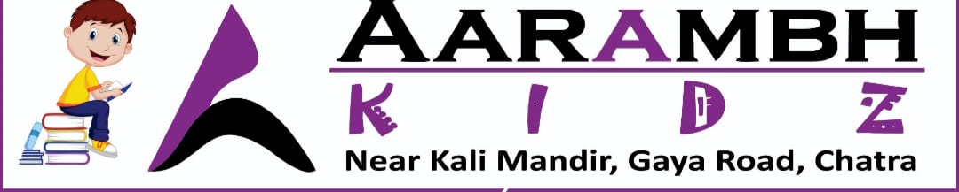

- Write down (10)
Sl No | Letter | For
1 | A
2 | C
3 | M
4 | O
5 | R
6 | F
7 | B
8 | G
9 | K
10 | L

2. Fill in the blanks with this and that : ( 5 )
Sl No | Picture | Color
a |  | _____________is a book .
b | 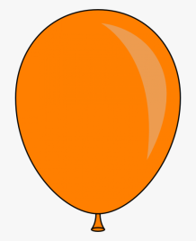 | _____________is a balloon .
c | ________ is a kite . | 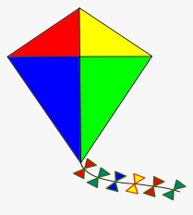
d | ________is a bat . | 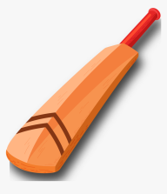
e | __________is a ball . | 
3.See the picture and write their name : ( 10 )
Sl No | Picture | Sl No | Picture
a | 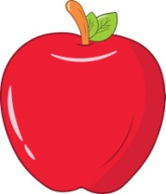 | f | 
b |  | g | 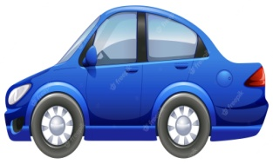
c |  | h | 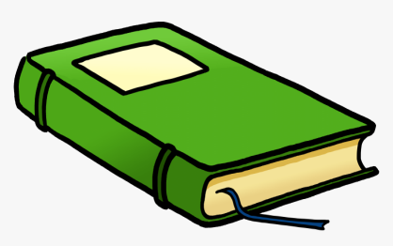
d | 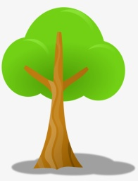 | i | 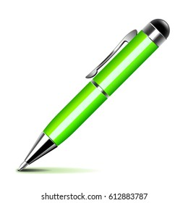
e | 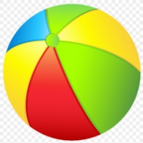 | j | 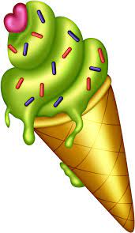
4. fill in the blanks with “a” or “an” : 10
_____girl | ____umbrella | _____apple | ______iron | ______egg | ________kite
______fish | _____onion | ______orange | _______eagle
5.circle the word Which is started with vowel : 5
Balloon igloo orange ice boy girl engine umbrella book pen pencil egg
Ant ice-cream box cat ball inkpot
Apple aroplane kite owl hut dog onion ant eagle iron flower bird orange apple

6.Fill in the blanks with” these” or “those” 5
Sl No | Picture | Color
a | 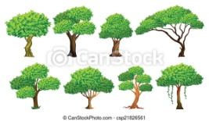 | _____________is a trees .
b | 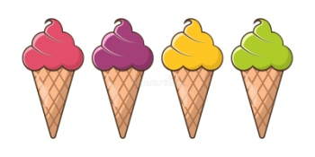 | _____________is a ice-creams .
c | ________ is a cups . | 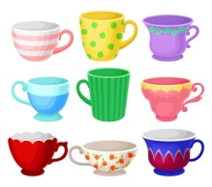
d | ________is a candles . | 
e | 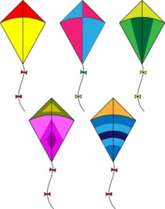 | _________ are kites .

7.Write the opposite words 5
Word | Opposite word
Cold
Long
Hard
Day
Fat

