CLASS : L.K.G. SUBJECT : ENGLISH (PICTURE ALBUM) FULL MARKS : 50 TIME : 2HRS
NAME: ………………………………………………………………………………………………………………………………… ROLL NO…………………………..
2nd SUMMATIVE EXAMINATION MARCH : 2023


- Write the answer of following questions (30)
- Who cooks the food ? ……………………………………………………………………………………………………………………………………………………………
- How many members are there in your family? ..................................................................................................................................................................
- Where does the children go to play ? ……………………………………………………………………………………………………………………………………………………
- Which animal is known as the king of Jungle ? ……………………………………………………………………………………………………………………………………………………
- Which animal gives us milk ? …………………………………………………………………………………………………………………………………………………
- Which animal gives us Egg ? …………………………………………………………………………………………………………………………………………………
- Write the name of yellow fruit ?
…………………………………………………………………………………………………………………………………………………
- Name two vegetables which are leaves of plant ?
…………………………………………………………………………………………………………………………………………………
- Name the vehicle which flies in the air ?
…………………………………………………………………………………………………………………………………………………
- Name the vehicle which is sailed in water ?
…………………………………………………………………………………………………………………………………………………
- Name two games you like the most ?
- What is the color of grass ?
…………………………………………………………………………………………………………………………………………………
- What is the color of your hair ?
…………………………………………………………………………………………………………………………………………………
- What is the shape of the coin ?
…………………………………………………………………………………………………………………………………………………
- What is the shape of sandwich ?
…………………………………………………………………………………………………………………………………………………
2. See the picture and write their color : ( 5 )
Sl No | Picture | Color
a | 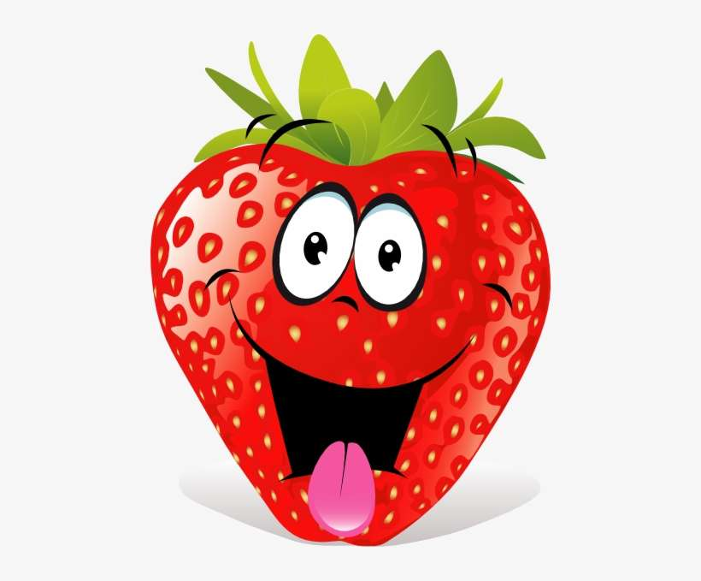
b | 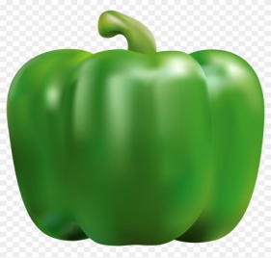
c | 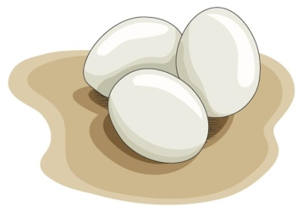
d | 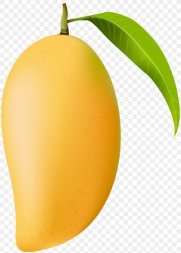
e | 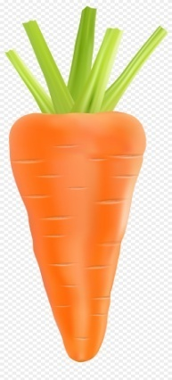
3.See the picture and write their name : ( 10 )
Sl No | Picture | Sl No | Picture
a | 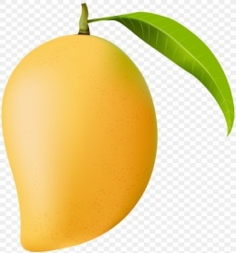 | f | 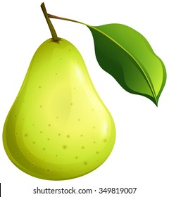
b | 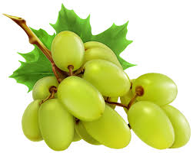 | g | 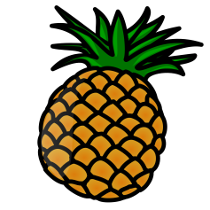
c | 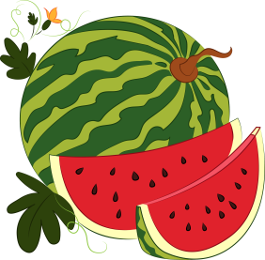 | h | 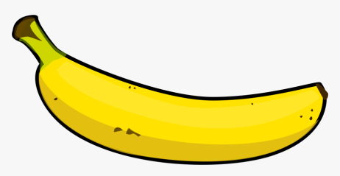
d | 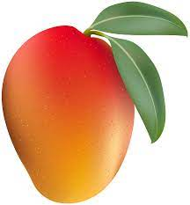 | i | 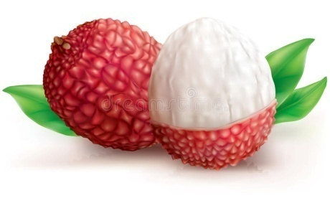
e | 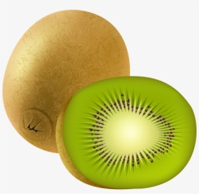 | j | 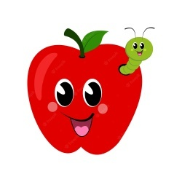
4. write the names of five animal : 5

