

2nd SUMMATIVE EXAMINATION MARCH : 2023
CLASS : NUR SUBJECT : ENGLISH FULL MARKS : 50 TIME : 2HRS
NAME: ………………………………………………………………………………………………………………………………… ROLL NO…………………………..

1.Write A to Z (5)

2. Write a to z (5)

2. Match the picture with correct letter (5)
Sl no | Picture | First letter of Picture
a | 
b | 
c | 
d | 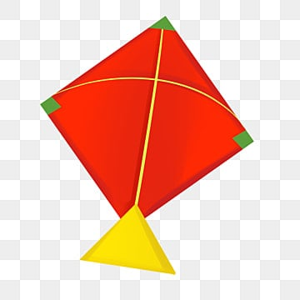
e | 

4. Match capital letter with small letter (10)
Sl No | Capital letter | Small letter
1 | A | f
2 | B | i
3 | C | g
4 | D | j
5 | E | h
6 | F | a
7 | G | k
8 | H | b
9 | I | l
10 | J | c
11 | K | d
12 | L | m
13 | M | e
14 | N | q
15 | O | r
16 | P | s
17 | Q | t
18 | R | p
19 | S | o
20 | T | n

5. What comes after (5)
Sl no | Letter | After | Sl no | Letter | After
1 | B |  | 6 | L
2 | J |  | 7 | N
3 | T |  | 8 | K
4 | R |  | 9 | P
5 | D |  | 10 | S
6.See and write 10
A | B | C | D | E | F | G | H | I | J
7.Write the missing alphabet 10
A |  | C |  |  |  | G |  |  | J
 |  |  |  | O |  |  |  |  | T
U | V |  |  |  |  |  |  | Z

a |  |  |  |  | f |  |  |  | j
 |  |  | n |  |  |  |  |  | t
 |  | w |  |  |  |  |  | z

