CLASS : NUR SUBJECT : ENGLISH (PICTURE ALBUM) FULL MARKS : 50 TIME : 2HRS
NAME: ………………………………………………………………………………………………………………………………… ROLL NO…………………………..
2nd SUMMATIVE EXAMINATION MARCH : 2023


- Write their ” Hindi” meaning (5)
- Father ……………………….. (b) Mother ……………………….. (c)Sister ……………………………………
d) Brother ………………………………………… (e)Grand Mother …………………………………………………………….
2. See the picture and write their name: ( 5 )
Sl No | Picture | Name
a | 
b | 
c | 
d | 
e | 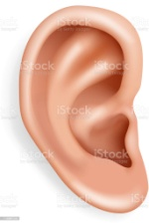
3.See the picture and write their first letter : ( 10 )
Sl No | Picture | Sl No | Picture
a |  | f | 
b |  | g | 
c |  | h | 
d |  | i | 
e |  | j | 
4. See the picture and write their first letter : ( 10 )
Sl No | Picture | Sl No | Picture
a |  | f | 
b |  | g | 
c |  | h | 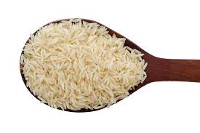
d |  | i | 
e |  | j | 
5. See the picture and write their name: ( 10 )
Sl No | Picture | Sl No | Picture
a |  | d | 
b |  | e | 
c | 

6. See the picture and write their color: ( 10 )
Sl No | Picture | Sl No | Picture
a |  | f | 
b |  | g | 
c |  | h | 
d |  | i | 
e |  | j | 

The End
7. Match the addition with their answer:-

