CLASS : Pre Nursery SUBJECT : HINDI FULL MARKS : 50 TIME : 2HRS
NAME: ………………………………………………………………………………………………………………………………… ROLL NO…………………………..
2nd SUMMATIVE EXAMINATION MARCH : 2023


1- Loj dks Loj ls feykb,A

v vks
, va
vks v
_ ,
va va

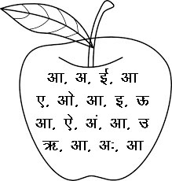
2- vk Loj ij xksy cukb,A

3- vyx Loj esa ?ksj yxkbZ, %&

v v v vk v

b b b bZ b

m m m Å m

_ _ , _ _
4- vk Loj esa jax HkjksA

5- O;atu dks O;atu ls feykb,%&

d i
V d
i e
e V
t t

6- lgh o.kZ ij ?ksjk yxkb,%&

vk v b

bZ b m

Å m _

v va v%

, ,s vks

7- fn, x, Loj gkFk ?kqek, %&

8- d vkSj x oxZ ij ?ksjk yxk,A

d x [k x

p d V x d

r x /k d i

u x d V x

